Case A: Monthly Electric Bill

***Introduction:***This is a simple simulator using excel to forecast Malaysian domestic monthly electricity bill based by this year’s approved ICPT rate, KWTBB and service tax (2021). Users is asked to key in only the total monthly consumption (kWh) and outstanding bill with days delayed (if any), then the total amount charged will be calculated automatically. To allow a better understanding of users, instructions and method of calculation will also be provided in the spread sheet.

***Methodology:***

|  |  |
| --- | --- |
| Block Tariff (kWh) | Rate per kWh |
| First 200 kWh (1-200 kWh) per month | 0.218 |
| Next 100 kWh (201-300 kWh) per month | 0.334 |
| Next 300 kWh (301-600 kWh) per month | 0.516 |
| Next 300 kWh (601-900 kWh) per month | 0.546 |
| Next 901 kWh onwards per month | 0.571 |

The table above is the rate applied to each block tariff. For example, if the total consumption of the month is 350 kWh, the total bill of the month will be (200*0.218) + (100*0.334) + (50*0.516) = RM 102.80 without applying ICPT, KWTBB and service tax. Another example using spread sheet is shown below.

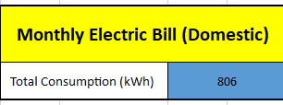

Table 1

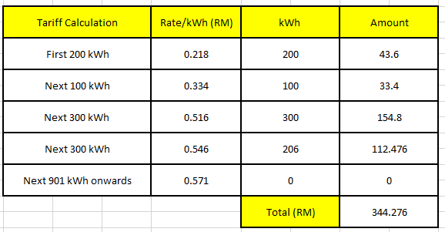

Table 2

The method to do the column kWh is using if-else statement which if the remaining kWh more than the maximum value set, let it be the maximum value, else use the remaining value.

The next step is to calculate the ICPT, KWTBB and service tax based on the value calculated above to get the net total amount to pay for the electricity bill (without outstanding bill). The rebate of ICPT is RM0.02 per kWh. Using the spread sheet example above, it will have a rebate of (806*0.02) RM 16.12. Other than that, the consumption of electricity (kWh) below 600 kWh will not be charged service tax. For example, an individual with total consumption of 800 kWh will be charged service tax for that particular 200 kWh only. For the KWTBB, it will be calculated based on the amount before inclusive the ICPT and service tax with 1.6% (Total amount on Table 2).

A clearer picture will be show on table below:

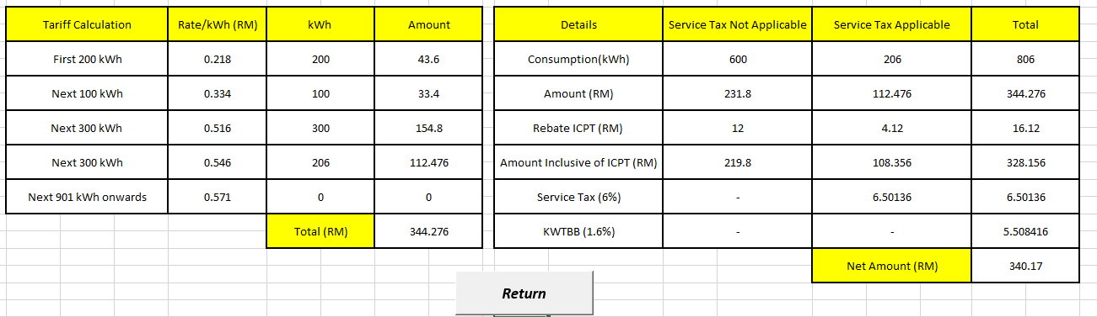

Table 3

Lastly, if users having an outstanding bill, they are allowed to key in the number of days delayed with the total outstanding amount to calculate the penalty charged by TnB.

The calculation of the penalty is:

1%*Total Outstanding amount*(number of days outstanding/30)

A spread sheet example is shown below:

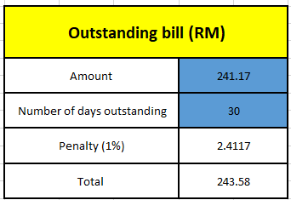

Table 4

***Conclusion:***

There are many individuals do not know how their bill be charged. By accessing this excel spread sheet, they can know how exactly the calculation be done due to the simple yet enough of the design and formula of the spread sheet.

Other than that, individuals who wanted to control their monthly personal budget can also access to this spread sheet to forecast their electricity bill for the coming month to control the usage of electricity.

A simple step will gain lots of information is very convenience and attractive which is the purpose of this excel spread sheet been created.

***Personal thoughts:***

This assignment allows me to further acknowledge the calculations and the ways electricity bill works. Also, lots of excel function have been exposed to me during this assignment which allow me to improve this assignment such as VBA.